\


Moodlakatte Institute of Technology
TRAINING AND PLACEMENT CELL
TOPIC
UI-PATH CITIZEN DEVELOPER
Organized On
19th December 2022-20th February 2023
Resource Person
UI-PATH
ICT ACADEMY

Contact Details
Phone No:
9500145522
vishnuprasad@ictacademy.in

Participants
Branch/ Section:
1st and second year BE students

Preamble
Robotic process automation (RPA) is a software technology that makes it easy to build, deploy, and manage software robots that emulate human actions interacting with digital systems and software. Like people, software robots can do things like understanding what’s on a screen, completing the right keystrokes, navigating systems, identifying, and extracting data, and performing a wide range of defined actions. But software robots can do it faster and more consistently than people, without the need to get up and stretch or take a coffee break!

REPORT
The Skill-A-Thon 2022, focused on UiPath Robotic Process Automation (RPA) and Citizen Developer skills, was conducted with the objective of fostering automation expertise and empowering participants to build 200 bots. The event aimed to provide hands-on experience in developing automation solutions using UiPath's RPA platform.
Training Objectives:
- The event aimed to enhance participants' skills in UiPath Robotic Process Automation (RPA) and specifically in the role of Citizen Developers
- The event aimed to provide participants with hands-on experience in developing bots. By working on real-world automation scenarios and challenges, participants gained practical knowledge and developed their problem-solving abilities.
- The event aimed to foster collaboration and networking among participants.
- A key objective of the event was to collectively build 200 bots. Participants were encouraged to work towards this milestone by leveraging their skills and expertise in UiPath RPA.
- The event aimed to promote the adoption of RPA and automation solutions.
Participants:
The event witnessed enthusiastic participation from first and second year engineering students from various colleges across Karnataka. Students from different disciplines showcased their interest in automation and displayed their creativity in building bots.

Event Highlights:
Training and Workshops:
Participants received training sessions and workshops conducted by experienced UiPath trainers. The training sessions introduced the basics of RPA and the UiPath platform, providing participants with a strong foundation in Citizen Developer skills.
Hands-on Bot Development:
Students actively engaged in hands-on bot development activities throughout the event. They were provided with real-world use cases and challenges that required them to apply their automation skills using the UiPath platform. This hands-on experience enabled them to enhance their problem-solving abilities and gain practical knowledge.
Competition and Recognition:
The event included a friendly competition where participants were tasked with building innovative bots. The bots were evaluated based on various criteria, including functionality, efficiency, creativity, and user experience. MITK, a participating team, secured first place in Karnataka and an impressive fourth place nationwide.
Mentorship and Guidance:
Expert mentors from the UiPath community provided continuous guidance and support to the participants. They shared best practices, reviewed the participants' work, and offered valuable insights to enhance their bot development skills. The mentorship ensured a high level of engagement and provided personalized assistance to the students.
Collaboration and Networking:
The event provided ample opportunities for collaboration and networking among the participants. Students interacted with fellow participants, shared ideas, and learned from each other's experiences. This collaborative environment fostered innovation and allowed participants to expand their professional networks.

Achievement of MITK:
MITK, a participating team from the event, demonstrated exceptional skills and creativity in building bots. Their hard work and dedication earned them the first-place position in Karnataka and an impressive fourth place in the national ranking. Their achievement is a testament to their commitment, problem-solving abilities, and the quality of their bot development.
Benefits and Outcomes:
- Participants enhanced their automation skills through hands-on bot development activities.
- The event encouraged participants to think innovatively and exhibit creativity in building bots. Students showcased their ability to identify automation opportunities, design efficient solutions, and create user-friendly interfaces.
- Participants gained valuable practical experience by working on real-world use cases and challenges.
- The event provided opportunities for collaboration and networking among participants. Students interacted with peers from different colleges, shared ideas, and learned from each other's experiences.
- Participants received mentorship and guidance from experienced UiPath professionals.
- The event recognized outstanding achievements by participants. MITK's first-place ranking in Karnataka and fourth place in India highlighted their exceptional skills and creativity.
- Participation in the event enhanced participants' career prospects in the field of automation.
- The event motivated and inspired participants to pursue automation and RPA as a career path. Witnessing the achievements of their peers and experiencing the impact of automation firsthand encouraged participants to further develop their skills and explore opportunities in the field.

- In conclusion, the UiPath Citizen Developer event for first and second year engineering students in building 200 bots resulted in positive outcomes and benefits. Participants developed their automation skills, fostered innovation and creativity, gained practical experience, and formed valuable professional connections. The event recognized outstanding achievements and motivated students to excel in the field of automation. The acquired skills and experiences will contribute to their career advancement and prepare them for the future of automation.
ORGANIZING COMMITTEE
Prof.Amruthmala-Dean TPIR
Prof.Akshatha Naik-Placement Officer
Prof.Manoj -Placement C0-ordiantor
FEEDBACK
Students: Students valued the practical experience gained through working on real-world use cases. They appreciated the relevance of the event to the industry and the exposure it provided to automation technologies and practices. The practical experience gave them a better understanding of the application of automation in various sectors.
WEBPAGE ADDRESS : https://www.ictacademy.in/skillathon/#skill
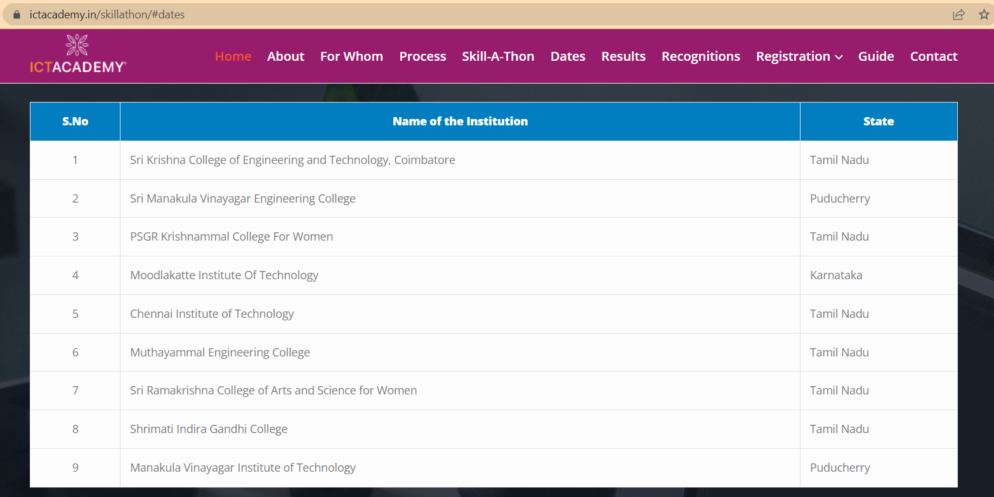
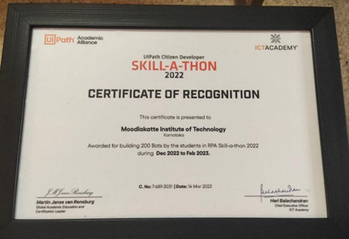 | 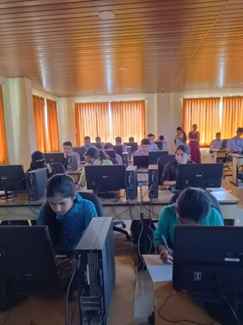
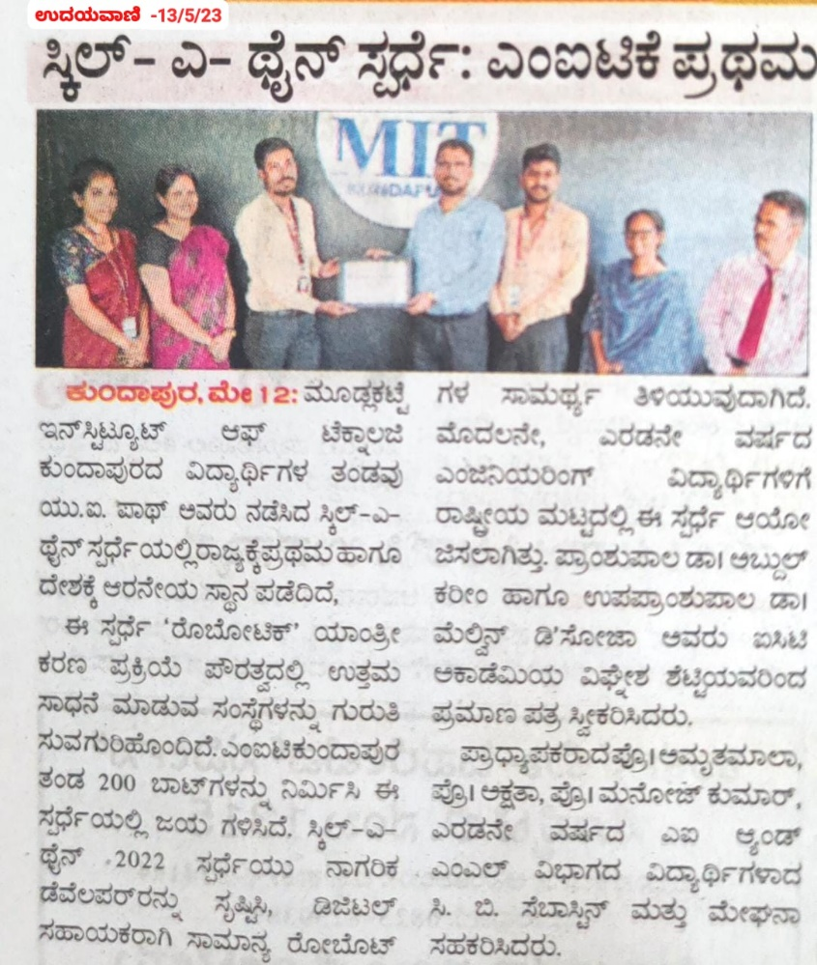
( https://www.ictacademy.in/skillathon/#recog )

_____________________________________________________________________________
Dean TPIR Principal

