
Moodlakatte Institute of Technology
Women Empowerment Cell

TOPIC
Gender Sensitization Program
Organized On
Date: 8th March 2023
Venue: Auditorium

Resource Person
- Mrs. Jennifer Menezes
Contact Details
JENEFER MENEZES
PH NO:9886153555

Participants

Participants
Branch/ Section: CSE/ECE/AIML First Year Students

Preamble
This gender sensitization programme seeks to promote awareness, empathy, and advocacy for gender equality. By challenging stereotypes, addressing discrimination and violence, and fostering inclusive policies and practices, we aim to create a society that respects and values individuals of all gender identities. Through open dialogue and learning, we strive to empower participants to become allies and advocates for positive change, contributing to a more equitable and inclusive society where everyone can thrive.

BRIEF PROFILE OF THE CHIEF GUEST:

Mrs Jennifer Menezes is the Principal of Moodlakatte College Of Nursing and is active public speaker who actively participate in educating women on health and safety.
REPORT
On Behalf of Women’s Day, Women Empowerment cell of MIT Kondapur had organized Gender Sensitization Programme on 8/3/2023. After inaugurating the programme, Mrs Jennifer Menezes explained the difference between Gender and Sex and also explained about the role of women in the society and also had a discussion with the students about their perspective. Principal of the college, Dr. Abdul Karim, Vice Principal Prof. Melvin de Souza, Asst Professor Mrs Pavana welcomed the gathering and Mrs Akshatha Naik offered vote of thanks.

ORGANIZING COMMITTEE
Staff co-coordinators
Mrs. Akshatha Naik
Mrs. Pavana

Student Coordinators:
Mr. Fathima 3rd Sem ECE
Mr. Sinchana Devadiga 3rd Sem ECE

FEEDBACK
Resource person: The Programme was well planned and properly executed. The response from students was good.

Students and Parents: Programme was interesting and informative. And Students exchanged their thoughts and experiences for the same.
Photo
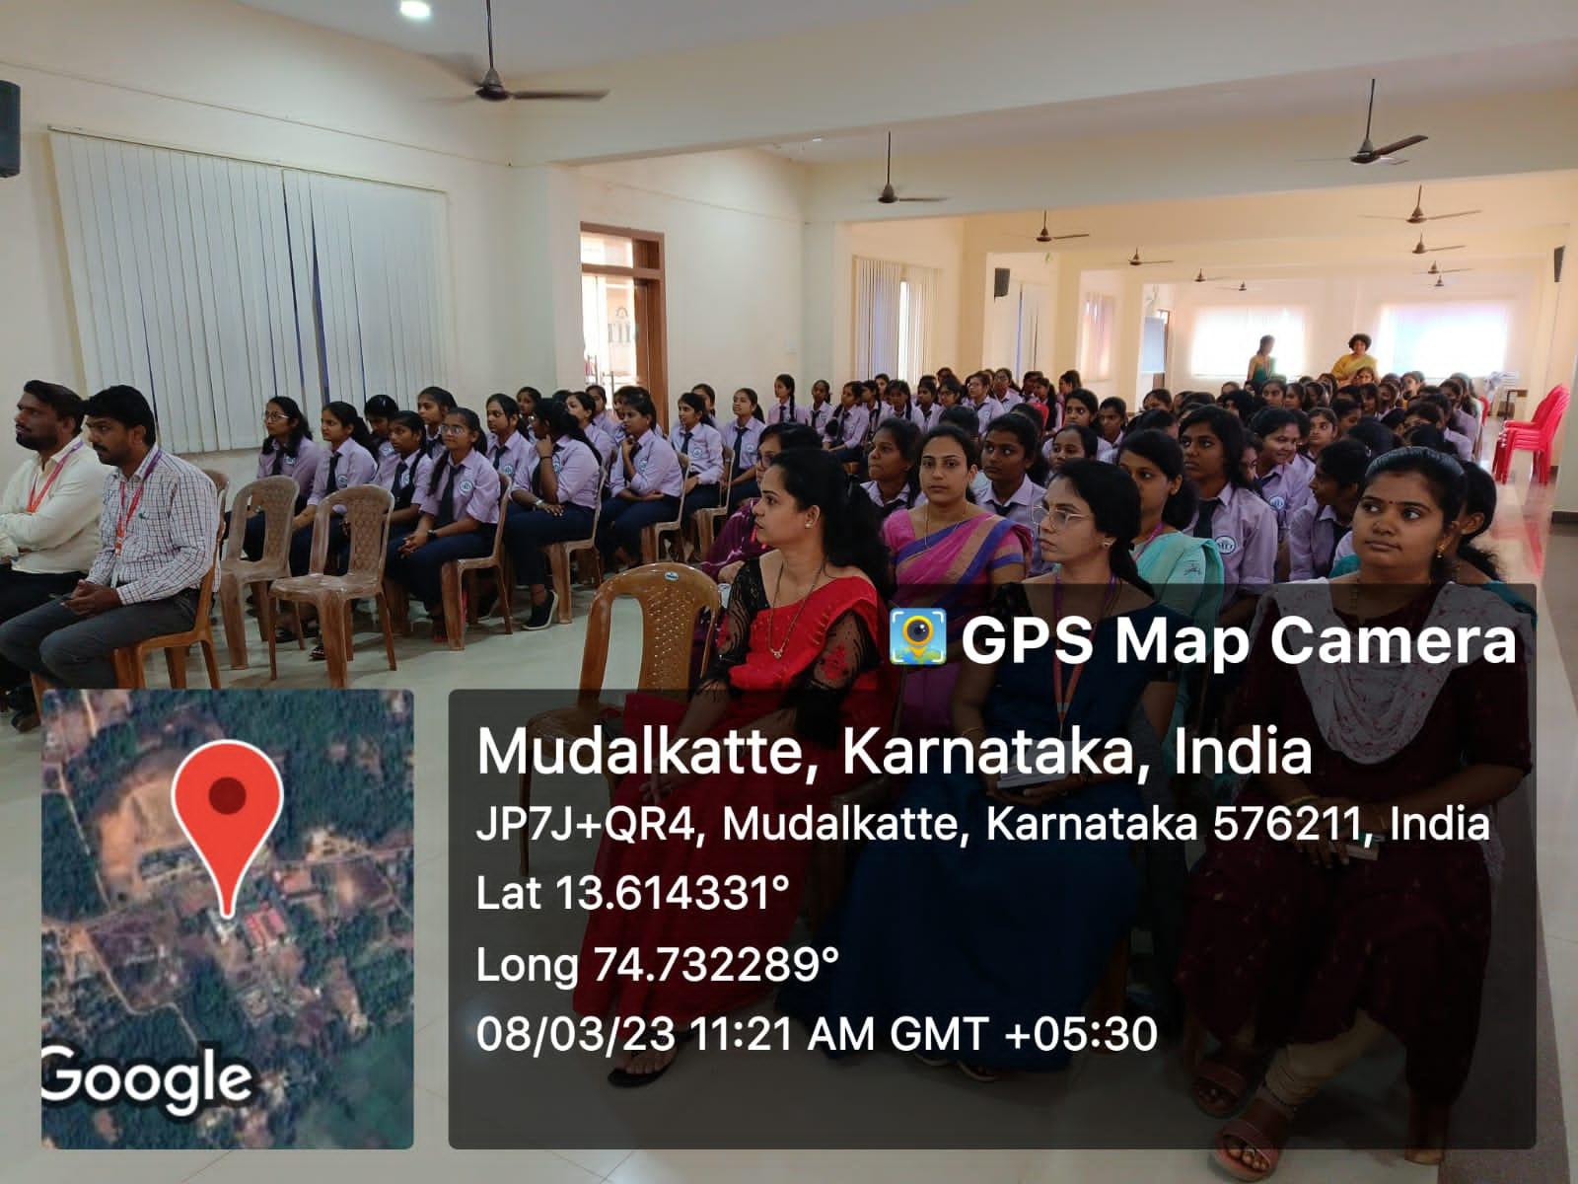

Prepared by: Prof. Signature/Seal of the HOD/Principal

