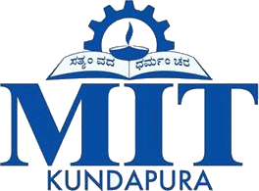
Moodlakatte Institute of Technology
Women Empowerment Cell
TOPIC
Talk Show on Gender Equality
Organized On
Date:11th March 2023
Venue: Auditorium

Resource Person
Judith Mendonca
Contact Details
Member Of JCI Kundapura Branch

Participants
Branch/ Section: Ist Year B.E Students

Preamble
Welcome to "Breaking Barriers: The Pursuit of Gender Equality," a talk show dedicated to fostering understanding, challenging stereotypes, and advancing the cause of true gender equality. With a commitment to celebrating achievements, acknowledging challenges, and embracing diverse perspectives, we unite in this collective pursuit of a more just, equitable, and compassionate society. Through engaging conversations and expert insights, we aim to ignite a passion for change, create a safe space for sharing stories, and inspire action towards dismantling barriers and building a world where every individual can thrive and contribute, irrespective of their gender. Join us on this enlightening journey as we amplify voices of change and sow the seeds of a brighter, inclusive future for generations to come.

BRIEF PROFILE OF THE CHIEF GUEST:

Mrs Judith Mendonca is an social activist and public speaker and an active member of JCI Kundapura Branch
REPORT
The talk show of Gender Equality" was a resounding success, with a focus on fostering understanding and advancing the cause of true gender equality. The show's engaging conversations, expert insights, and diverse perspectives illuminated the challenges and achievements in the ongoing struggle for gender parity. By celebrating the accomplishments of trailblazers and exploring the importance of dismantling patriarchal norms, the show sparked meaningful discussions. It emphasized the significance of men as allies and recognized the contributions of non-binary and gender-nonconforming individuals. Attendees left inspired and committed to taking action in their respective spheres of influence to create a more just, equitable, and compassionate society where everyone can thrive, irrespective of their gender. "Breaking Barriers" truly amplified voices of change, leaving a lasting impact and sowing the seeds for a brighter, more inclusive future. Principal of the college, Dr. Abdul Karim, Vice Principal Prof. Melvin de Souza, Head of the Department Professor Balanageshwar, Head of the Department of Artificial Intelligence Professor Varuna kumar, staff, students were present. Professor Sushma Shetty welcomed, student Sinchana Devadiga delivered vote of thanks, Fatima narrated.

ORGANIZING COMMITTEE
Staff co-coordinators
Mrs. Akshatha Naik
Mrs. Pavana

Student Coordinators:
Mr. Fathima 3rd Sem ECE
Mr. Sinchana Devadiga 3rd Sem ECE

FEEDBACK
Resource person: The program was well planned and properly executed. The response from students was good.

Students and Parents: The program was highly interactive and effective.

Photos
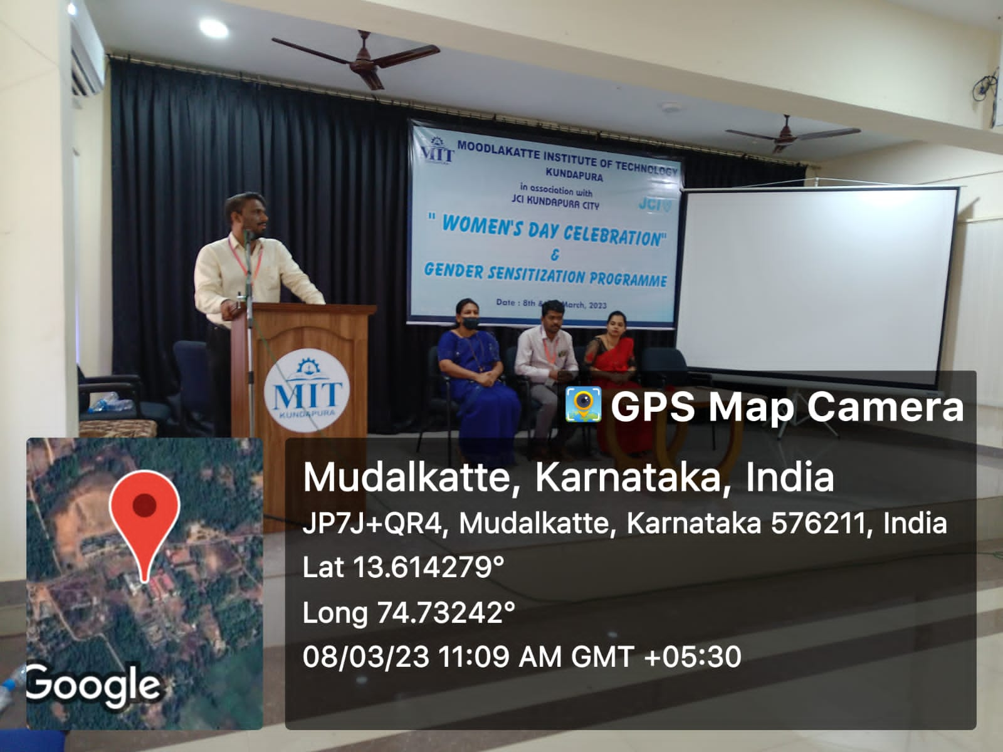

Signature/Seal of the HOD/Principal

